Experienmet-1: Monitoring Network Traffic

Objective: To analyze and capture network traffic to identify patterns, detect anomalies and assess overall network performance and security.

Launching Wireshark:

- Find Wireshark in your applications menu and launch it. You'll likely need administrative privileges to capture traffic.
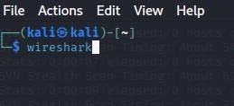

Selecting an Interface:

- Upon launching, Wireshark will show a list of available network interfaces (e.g., Ethernet, Wi-Fi). Select the interface through which you network traffic is flowing.
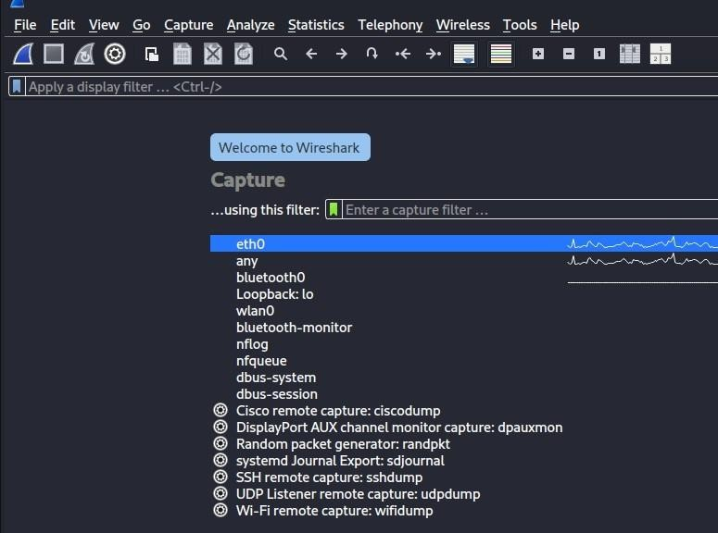

Starting Capture:

Click the blue "Start capturing packets" fin icon (or Capture -> Start) to begin capturing traffic on the selected interface.

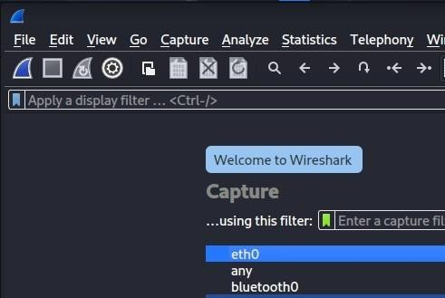

Generating Traffic (for analysis):

- Perform some network activities: browse websites, ping another machine, transfer a file, open an application that uses the network. This will populate your capture with packets to analyze.
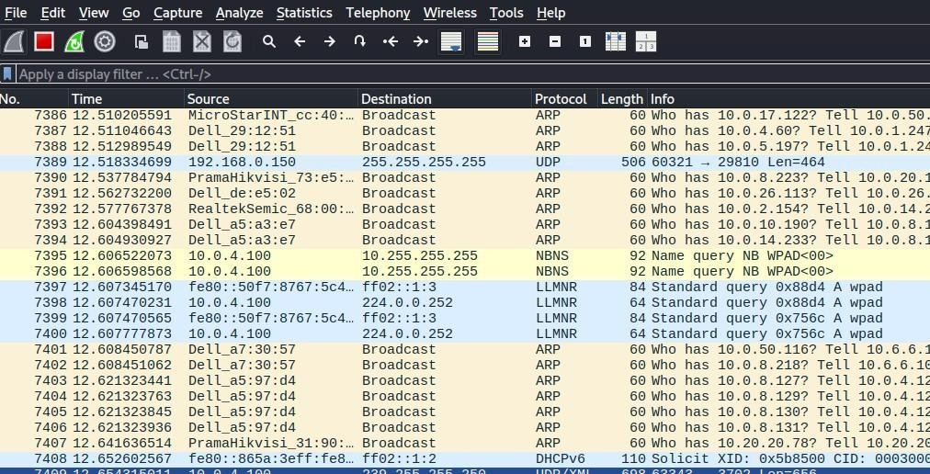

Stopping Capture:

- Click the red "Stop capturing packets" square icon (or Capture ->

Stop) to halt the capture.

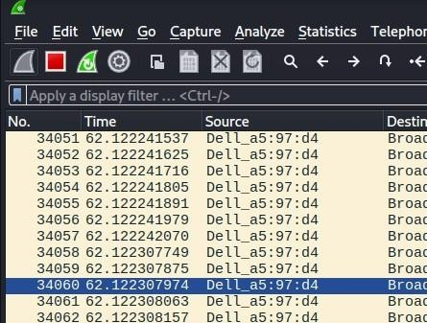

Analyzing Captured Traffic:
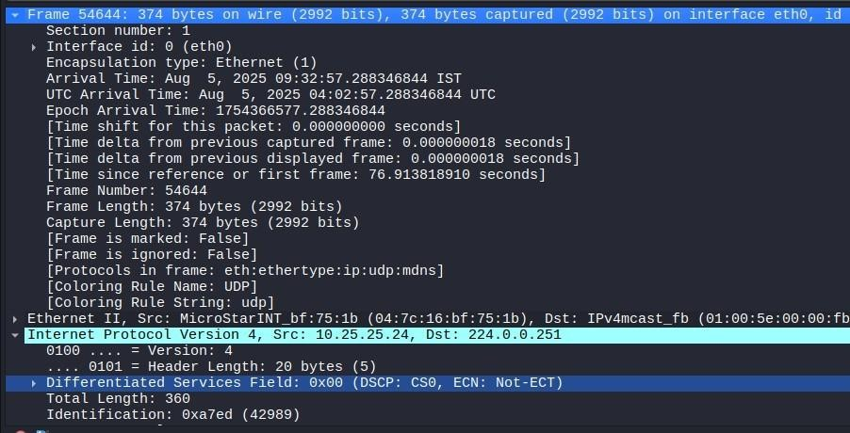

- Packet List Pane (Top): Shows a summary of each packet: number, time, source IP, destination IP, protocol, length, and information.
- Packet Details Pane (Middle): Expands on the selected packet from the top pane, showing the various layers of the network stack (Ethernet, IP, TCP/UDP, HTTP, etc.) and their details.
- Packet Bytes Pane (Bottom): Displays the raw hexadecimal and ASCII data of the selected packet.
- Filtering: Use the display filter bar at the top (e.g., http, dns,

ip.addr == 192.168.1.1, tcp.port == 80) to narrowdown the displayed packets and focus on specific traffic.

Experiment 2: OpenVAS (GVM) Local Installation on Kali Linux – Step-by-Step Guide

Objective: To perform a systematic assessment of networked systems using OpenVAS to identify potential vulnerabilities that could be exploited by attackers.

Update Your Kali System
>Sudo apt update && Sudo apt full-upgrade -y
  - Ensures all dependencies and core packages are up-to-date.

If errors persist — refresh sources.list
Open the file:
  - Sudo nano /etc/apt/sources.list
  - Make sure it only contains:
  - deb http://http.kali.org/kali kali-rolling main non-free contrib

Install OpenVAS / GVM
sudo apt install openvas -y
  - Installs:
    - gvmd (manager daemon)
    - openvas-scanner (scanner)
    - gsa (web interface)
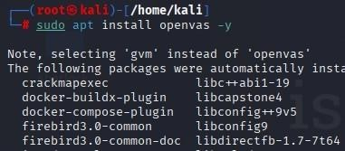

Run the Initial Setup
>Sudo gvm-setup
  - Creates DB for gvmd
  - Syncs NVT feeds
  - Generates SSL certs

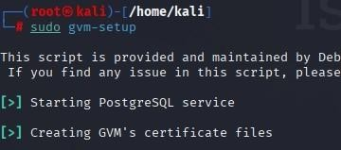
  - Creates admin user & password (shown at end)

If feed sync fails:
sudo runuser -u _gvm -- greenbone-nvt-sync
You can now run gvm-check-setup to make sure everything is correctly configured

> gvm-check-setup
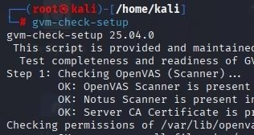

Enable & Start Services
sudo systemctl enable --now gvmd
sudo systemctl enable --now ospd-openvas sudo systemctl enable --now gsad

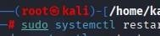

Verify Setup
sudo gvm-check-setup
  - Checks feed status, scanner linking, and certificates.
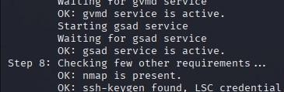

Access Web Interface
  - URL: https://127.0.0.1:9392
  - Accept SSL warning.
  - Login with:
    - Username: admin
    - Password: shown after setup
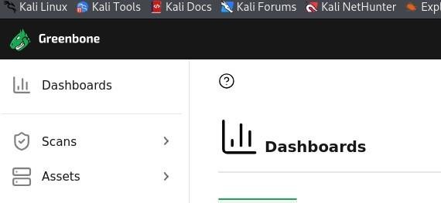

Reset Admin Password (if needed)
sudo gvmd --user=admin --new-password='MySecurePass123!'


Update Feeds
sudo greenbone-feed-sync --type GVMD_DATA sudo greenbone-feed-sync --type SCAP
sudo greenbone-feed-sync --type CERT
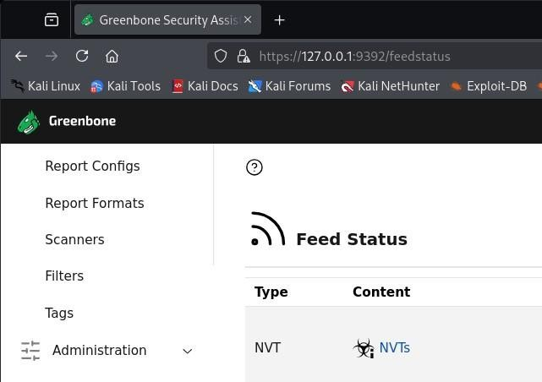

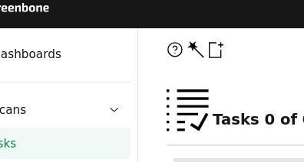

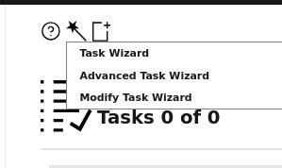

Viva Questions

Q1: What is the role of OpenVAS in vulnerability management?
A1: It scans systems for known vulnerabilities, misconfigurations, and weaknesses, providing reports for remediation.
Q2: What is the difference between vulnerability scanning and penetration testing? A2: Scanning is automated and identifies potential issues, while penetration testing is manual/targeted and exploits vulnerabilities.

Q3: What type of vulnerabilities can OpenVAS detect?
A3: Outdated software, weak passwords, misconfigured services, missing patches, and insecure protocols.

Q4: What is a CVE, and how does OpenVAS use it?
A4: CVE (Common Vulnerabilities and Exposures) is a unique identifier for known vulnerabilities. OpenVAS maps scan results to CVEs for standardized reporting.

Q5: Why is it important to regularly update OpenVAS feeds?
A5: To ensure the scanner can detect the latest vulnerabilities as new CVEs are discovered.

Experiment 3: Internal Penetration Testing
- Evaluating External Infrastructure
- Creating Topological Map & Identifying IP Address of Target
- Lookup Domain Registry for IP Information
- Examining Use of IPv6 at Remote Location

Objective: To conduct a comprehensive external penetration test aimed at evaluating the security of the organization's external infrastructure by assessing vulnerabilities, mapping the network topology, gathering IP and domain registry information, and examining the implementation of IPv6, ultimately identifying potential entry points and recommending measures to strengthen defenses against external threats.

Steps:

  - Mapping (using Nmap):

    - Identify Network Range: Determine the local network subnet (e.g., 192.168.1.0/24).
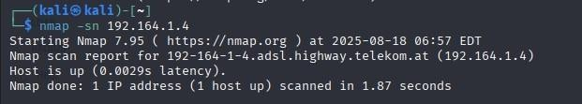
    - Ping Scan: nmap -sn 192.168.1.0/24 to find live hosts.
    - Generate a Topology Map
      - If you have Zenmap (GUI for Nmap):
- Zenmap

      - Run the same scan (nmap -sn 198.168.0.0/24).
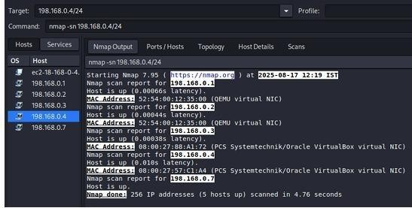

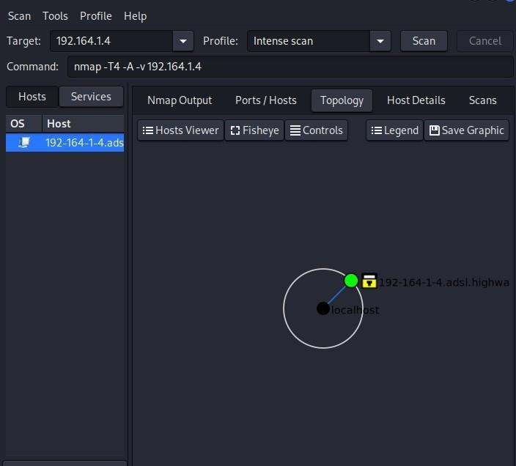
Go to the Topology Tab → It shows a network map diagram (nodes + links).
Expected Result: You’ll have a visual map of the subnet with your target highlighted.

Scanning (using Nmap, manual vulnerability checks):

Vulnerability Script Scan:
- nmap -sV --script vuln 192.168.1.X to run Nmap's built-in vulnerability scripts against identified services.
- nmap -sV -p- -O 192.168.1.4 for each live host to identify open ports, services, and OS. This covers initial mapping of services.
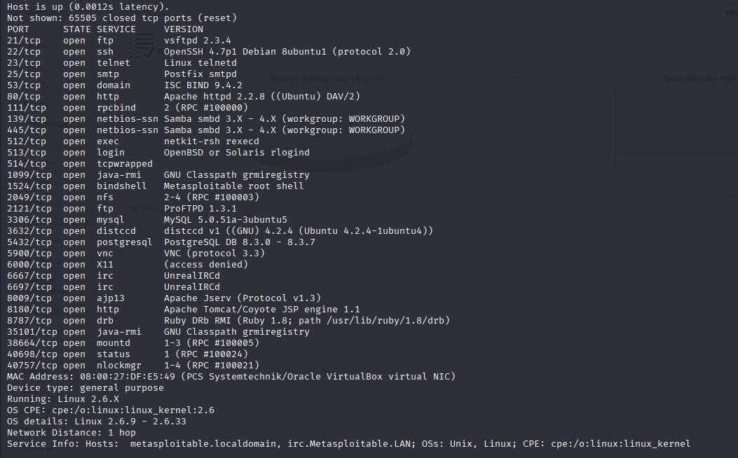

Note>
Manual Checks: Based on identified service versions, cross-reference them with public vulnerability databases (e.g., CVE Details, Exploit-DB) to find known exploits.

Gaining Access through CVEs (using Metasploit Framework): Lab Setup
We’ll use two VMs:
    - Kali Linux → the attacker machine.
    - Metasploitable 2 → the target machine (it has many vulnerabilities for learning).
In VirtualBox:
      - Put both in the same NAT Network (not Bridged, not Host-Only).
      - Start both.
      - In Metasploitable2, log in (msfadmin / msfadmin) and run: ifconfig
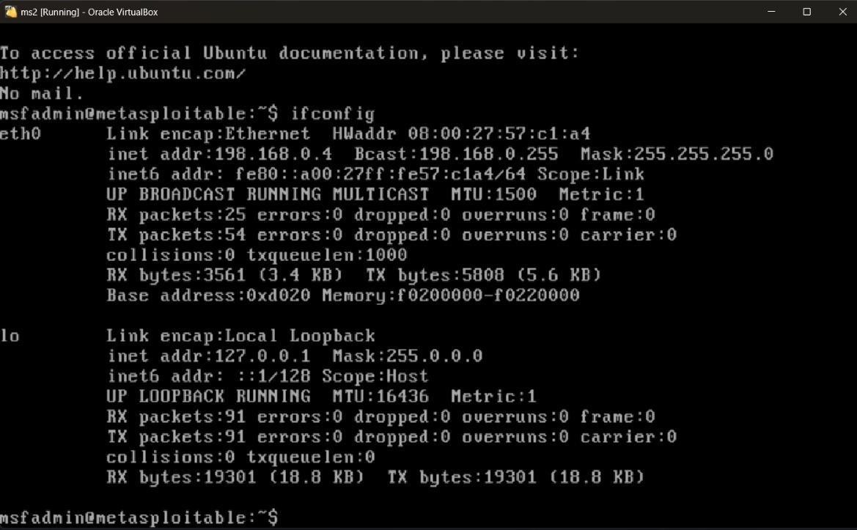

a. Evaluating External Infrastructure
Goal: Find what services (ports) are exposed, what software they run, and possible vulnerabilities.

Ping the Target
This checks if the host is alive and gives you round-trip times.

  - ping -c 4 198.168.0.4(ping -c 4 TARGET_IP)

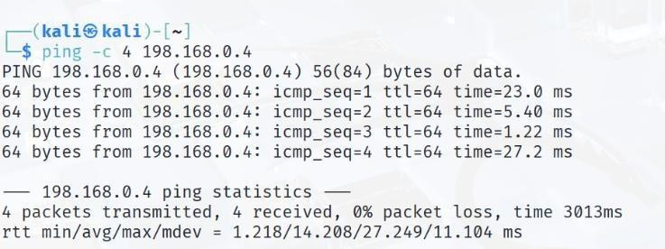
Expected:
- If host is up, you’ll see replies with time=xx ms.
- If host is down, you’ll see Destination Host Unreachable or Request timed out.

Basic scan — find open ports:
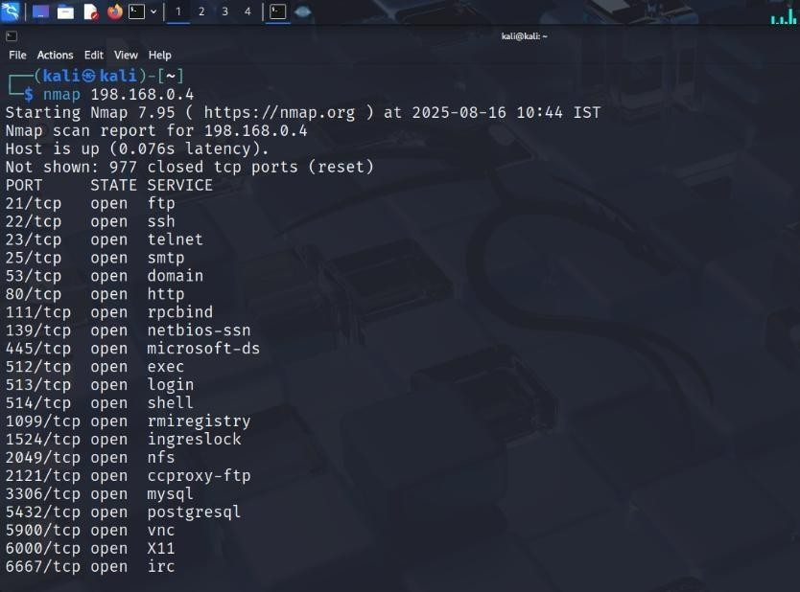
  - nmap 198.168.0.4(nmap TARGET_IP)
- You’ll see a list of open ports (like 21, 22, 23, 80, etc.).

Detailed scan — detect versions and OS:
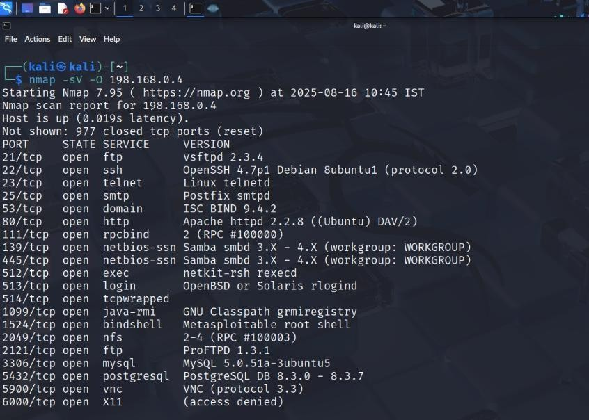
  - nmap -sV -O 198.168.0.4

You’ll see a list of open ports (like 21, 22, 23, 80, etc.).
- -sV → service version detection
- -O → OS detection
- This will tell you something like vsftpd 2.3.4 or Apache httpd 2.2.8.

Vulnerability scripts:

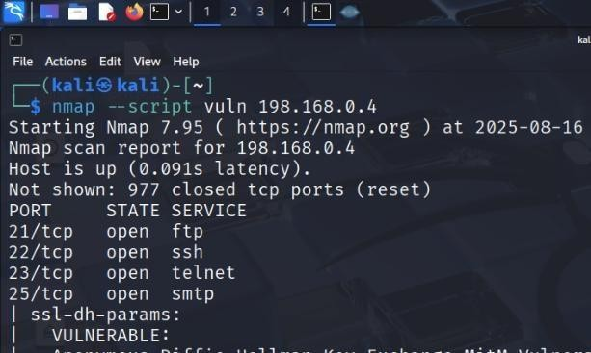
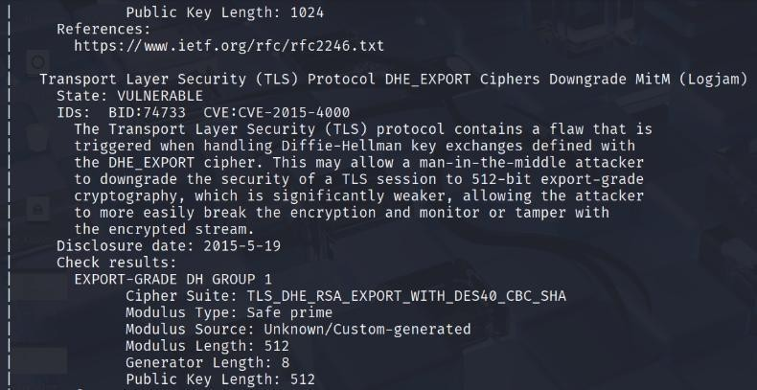
  - nmap --script vuln 198.168.0.4
Runs safe vulnerability scripts that identify common issues. NOTE:
- The --script vuln option runs all vulnerability NSE scripts (~100+) from Nmap’s scripting engine.
- Each script tries to probe the target for known CVEs, weak configurations, etc.
- Many scripts take a long timeout (30–60 seconds per port/service).
- If your target (Metasploitable VM) is not responding fast or some ports are filtered, Nmap keeps retrying.
So on a slow VM or NAT network, it looks like it’s “stuck.”

What you can do instead

Basic service discovery first (fast scan):
  - nmap -sS -sV -T4 198.168.0.4

- -sS → SYN scan (faster, stealthy)
- -sV → detect service versions
- -T4 → faster timing
This gives you a quick idea of which services are open.

Run vulnerability scripts only on open ports:
Suppose from step 1 you see 21/tcp (FTP), 22/tcp (SSH), 80/tcp (HTTP) are open.
Instead of scanning everything, target those ports only:
  - nmap --script vuln -p 21,22,80 198.168.0.4

Use specific scripts instead of all vuln:
Examples:

For FTP misconfigurations:
  - nmap --script ftp-anon -p 21 198.168.0.4

For SMB:
  - nmap --script smb-vuln* -p 445 198.168.0.4

For HTTP:
  - nmap --script http-vuln* -p 80 198.168.0.4 This is much faster and still gives useful results.

Use Metasploit for exploitation

Once you have service versions, jump into Metasploit:
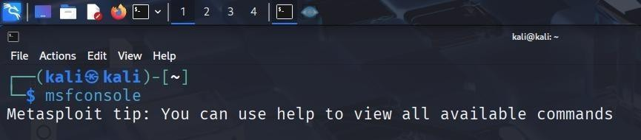
  - Msfconsole
From the msf6 > prompt, search for the exploit:
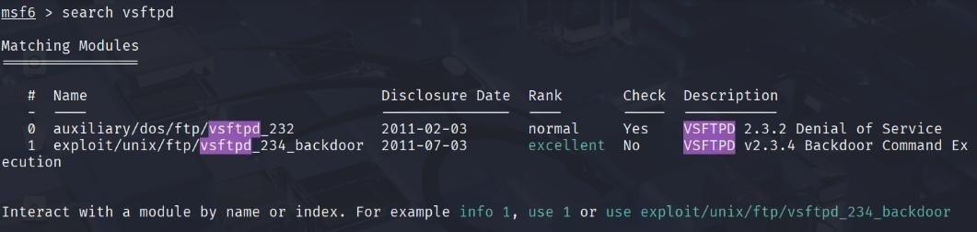
  - search vsftpd

You’ll see something like: exploit/unix/ftp/vsftpd_234_backdoor
Load the exploit module:
  - use exploit/unix/ftp/vsftpd_234_backdoor

Check the required options:
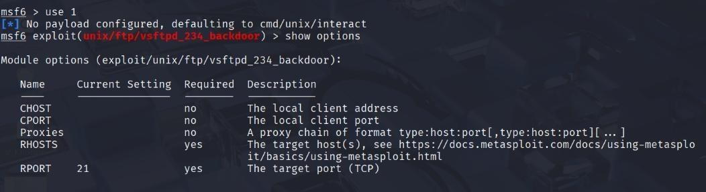
  - show options

Set the target IP (your Metasploitable2 VM, e.g., 198.168.0.4):
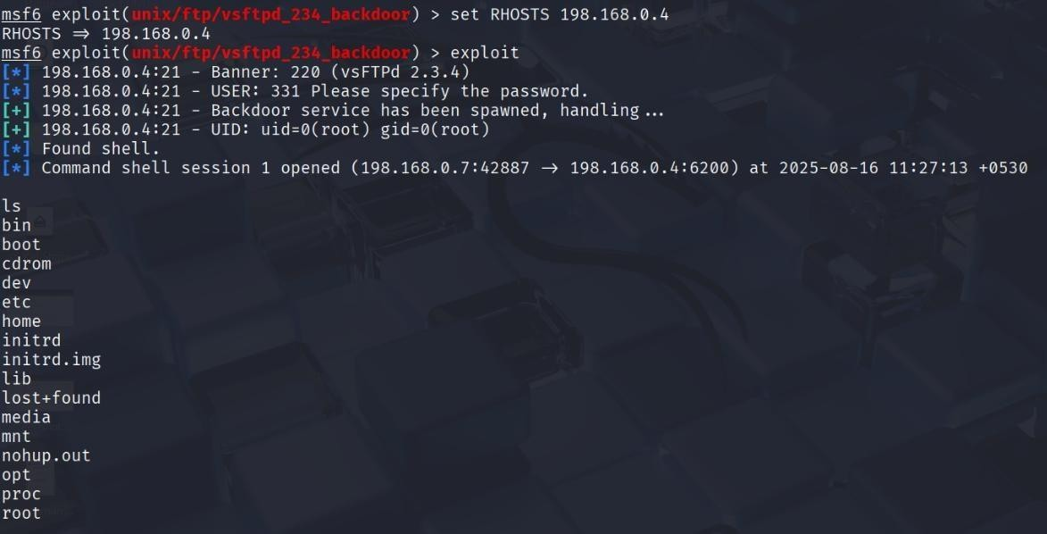
  - set RHOSTS 198.168.0.4

Run the exploit:
  - exploit

Sniffing POP3/FTP/Telnet Passwords (using Wireshark):

Start Wireshark Capture: Begin a capture on your network interface.

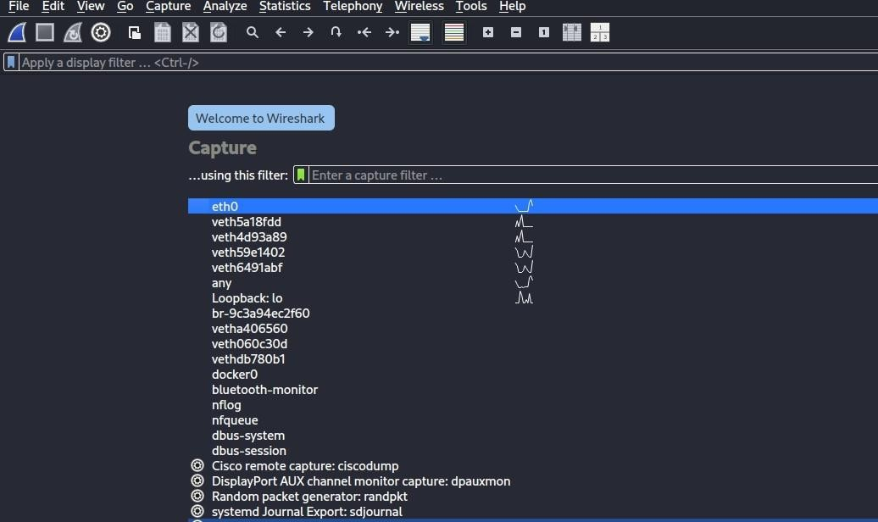

Visit the website www.vulnweb.com
>Select the Second link provided in the Image http://testphp.vulnweb.com/
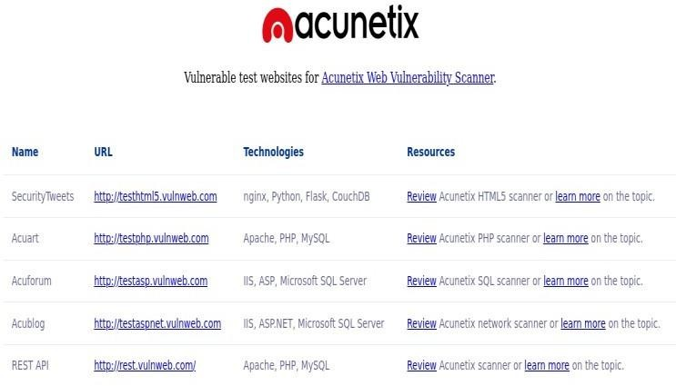

Select the signup page Provide
Uname=test Pass=test

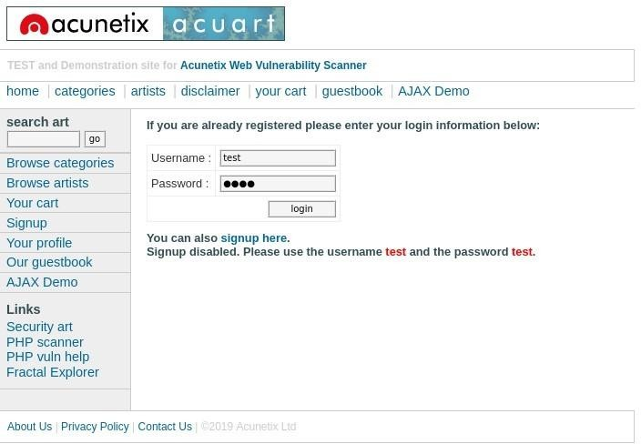
Select the filter Apply http protocol
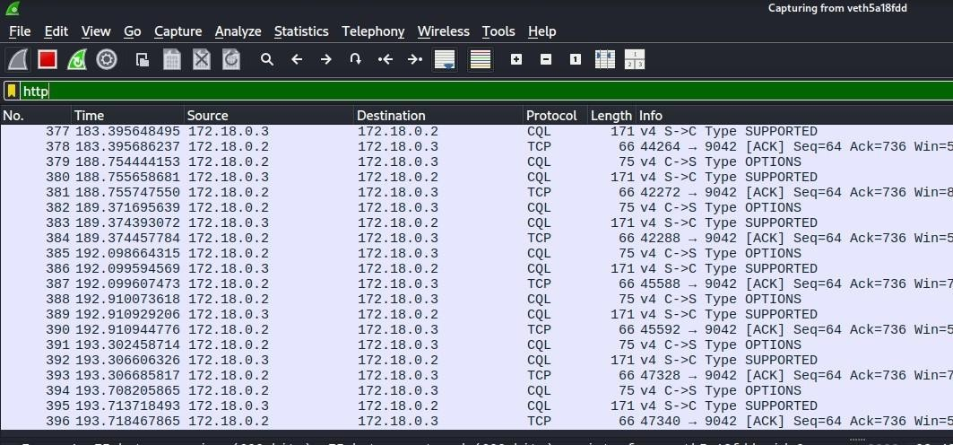

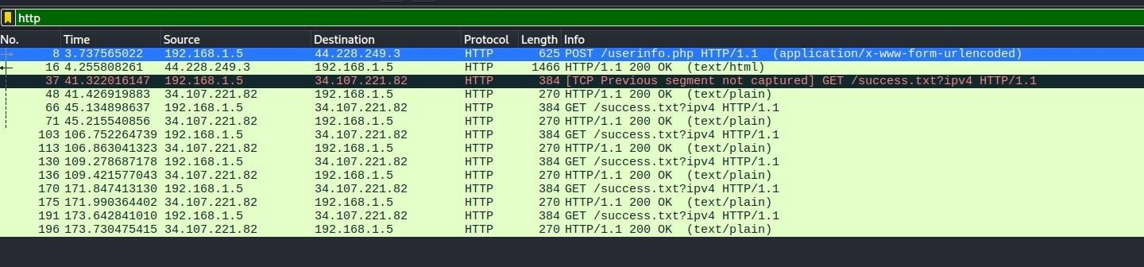
Select POST request userinfo.php

Extend the HTML Form URL Encoded U scan see the key and value “previously entered credentials”
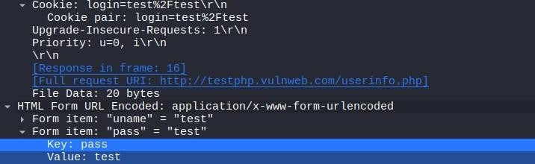

ARP Poisoning (using Ettercap):

    - Launch Ettercap (GUI or CLI): sudo ettercap -G for GUI,
or sudo ettercap -T -q -i eth0 -M arp:remote /target1/ /target2/ for CLI. Select Interface: Choose your network interface.
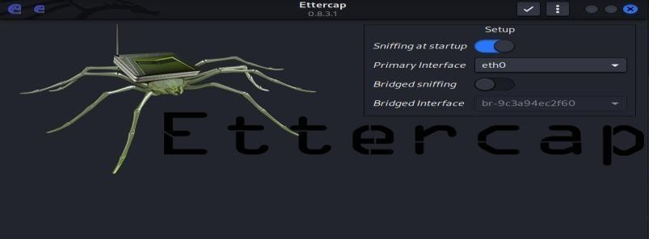
    - Add Targets: Add your Metasploitable IP as Target 1
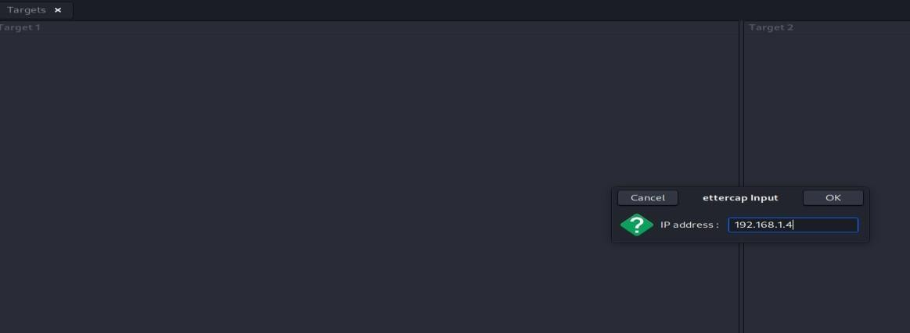
    - Start MITM Attack: Select "Mitm -> ARP poisoning -> Sniff remote connections".
    - Start Sniffing: Start the unified sniffing (Start -> Start sniffing).

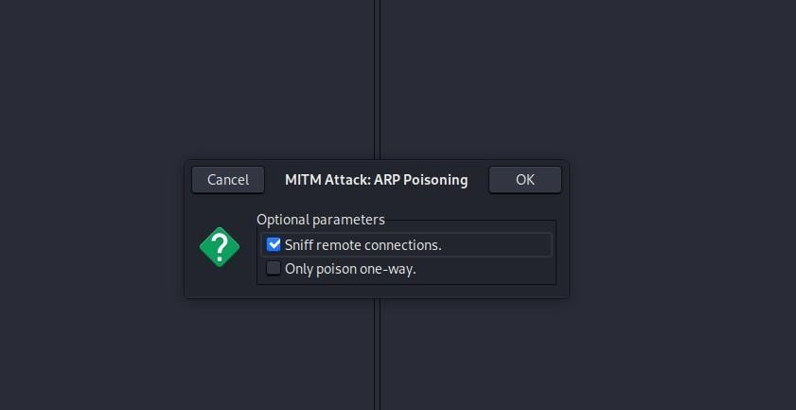
Observe: Traffic between the victim and gateway will now pass through your machine. You can use Wireshark simultaneously to observe this redirected traffic.
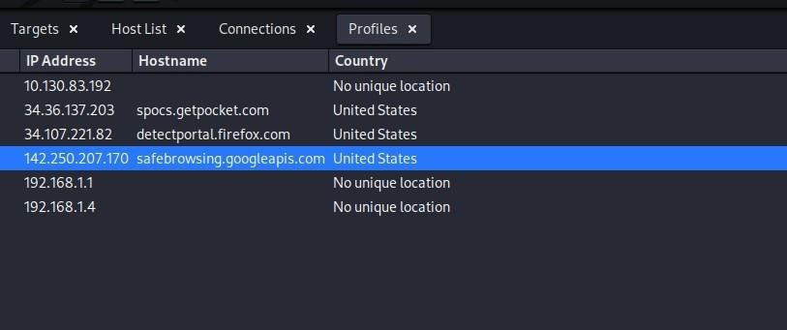
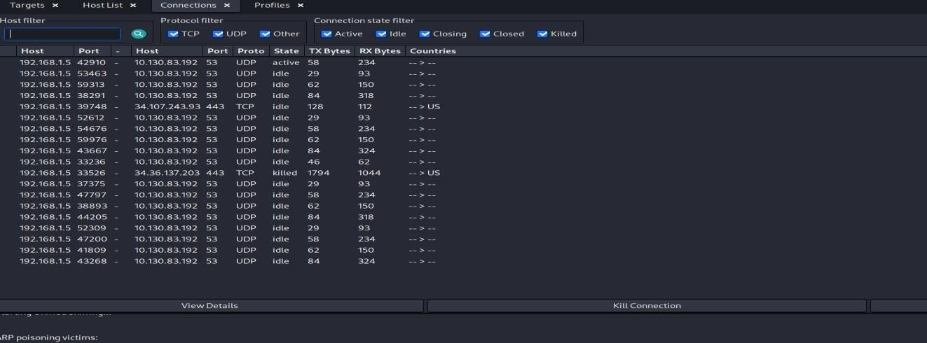

DNS Poisoning (using Ettercap or bettercap):

    - Ettercap (requires setting up a etter.dns file):
- Edit /etc/ettercap/etter.dns to add a malicious DNS entry, e.g., www.example.com A 1.2.3.4 (where 1.2.3.4 is your malicious server or a web server you control).
- Start ARP poisoning as above.
- Enable DNS spoofing plugin: "Plugins -> Manage plugins -> dns_spoof".
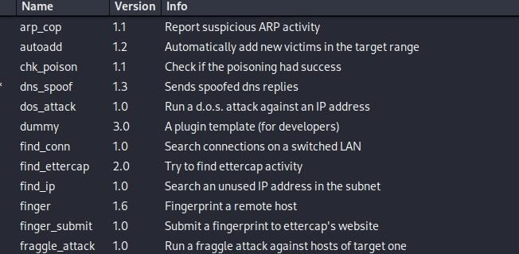
- When the victim tries to resolve www.example.com, they will get your spoofed IP.

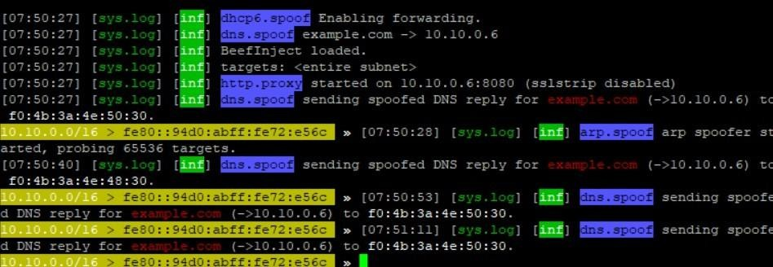

Viva Questions

Q1: What is the purpose of internal penetration testing?
A1: To simulate insider threats or compromised devices and assess security risks within the internal network.

Q2: How is network mapping performed during penetration testing?
A2: By using tools like Nmap, ARP scans, and traceroute to identify hosts, devices, and topology.

Q3: Give one method to sniff credentials in internal networks.
A3: Using tools like Wireshark or Ettercap to capture unencrypted POP3/FTP/Telnet traffic.

Q4: What is ARP poisoning, and why is it dangerous?
A4: ARP poisoning manipulates ARP tables to redirect traffic through the attacker, enabling man-in-the-middle attacks.

Q5: How does DNS poisoning work?
A5: By corrupting DNS cache entries to redirect domain queries to malicious IP addresses.

Experiment 4: External Penetration Testing

Objective: To conduct a comprehensive external penetration test aimed at evaluating the security of the organization's external infrastructure by assessing vulnerabilities, mapping the network topology, gathering IP and domain registry information, and examining the implementation of IPv6, ultimately identifying potential entry points and recommending measures to strengthen defenses against external threats.

Lab Setup
We’ll use two VMs:
- Kali Linux → the attacker machine.
- Metasploitable 2 → the target machine (it has many vulnerabilities for learning). In VirtualBox:
  - Put both in the same NAT Network (not Bridged, not Host-Only).
  - In Metasploitable2, log in (msfadmin / msfadmin) and run:

- ifconfig

Evaluating External Infrastructure
Goal: Find what services (ports) are exposed, what software they run, and possible vulnerabilities.
- Ping the Target
This checks if the host is alive and gives you round-trip times.

  - ping -c 4 198.168.0.4(ping -c 4 TARGET_IP)
Expected:
- If host is up, you’ll see replies with time=xx ms.
- If host is down, you’ll see Destination Host Unreachable or Request timed out.

Basic scan — find open ports:
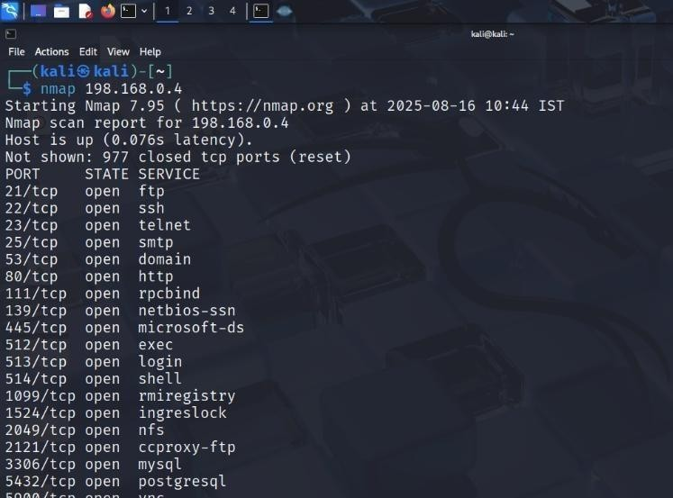
- nmap 198.168.0.4(nmap TARGET_IP)
- You’ll see a list of open ports (like 21, 22, 23, 80, etc.).

Detailed scan — detect versions and OS:
- nmap -sV -O 198.168.0.4

You’ll see a list of open ports (like 21, 22, 23, 80, etc.).
- -sV → service version detection
- -O → OS detection
- This will tell you something like vsftpd 2.3.4 or Apache httpd 2.2.8.

Vulnerability scripts:
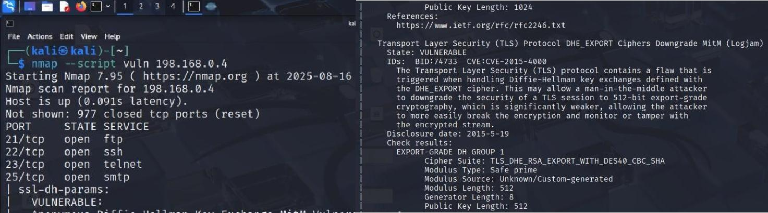
- nmap --script vuln 198.168.0.4
Runs safe vulnerability scripts that identify common issues. NOTE:
- The --script vuln option runs all vulnerability NSE scripts (~100+) from Nmap’s scripting engine.
- Each script tries to probe the target for known CVEs, weak configurations, etc.
- Many scripts take a long timeout (30–60 seconds per port/service).
- If your target (Metasploitable VM) is not responding fast or some ports are filtered, Nmap keeps retrying.
So on a slow VM or NAT network, it looks like it’s “stuck.”

What you can do instead
Basic service discovery first (fast scan):
- nmap -sS -sV -T4 198.168.0.4
- -sS → SYN scan (faster, stealthy)
- -sV → detect service versions
- -T4 → faster timing
This gives you a quick idea of which services are open.

Run vulnerability scripts only on open ports:
Suppose from step 1 you see 21/tcp (FTP), 22/tcp (SSH), 80/tcp (HTTP) are open. Instead of scanning everything, target those ports only:
- nmap --script vuln -p 21,22,80 198.168.0.4 Use specific scripts instead of all vuln: Examples:

For FTP misconfigurations:
- nmap --script ftp-anon -p 21 198.168.0.4

For SMB:
- nmap --script smb-vuln* -p 445 198.168.0.4

For HTTP:
- nmap --script http-vuln* -p 80 198.168.0.4 This is much faster and still gives useful results.

Use Metasploit for exploitation
Once you have service versions, jump into Metasploit:
- Msfconsole
From the msf6 > prompt, search for the exploit:
- search vsftpd
You’ll see something like: exploit/unix/ftp/vsftpd_234_backdoor
Load the exploit module:
- use exploit/unix/ftp/vsftpd_234_backdoor
Check the required options:
- show options

Set the target IP (your Metasploitable2 VM, e.g., 198.168.0.4):
- set RHOSTS 198.168.0.4
Run the exploit: exploit

Creating Topological Map & Identifying IP Address of Target
Goal: Visualize the path from your machine to the target and confirm its IP.

Discover live hosts in the subnet
  - nmap -sn 198.168.0.0/24
- -sn → Ping Scan (host discovery only, no port scan).
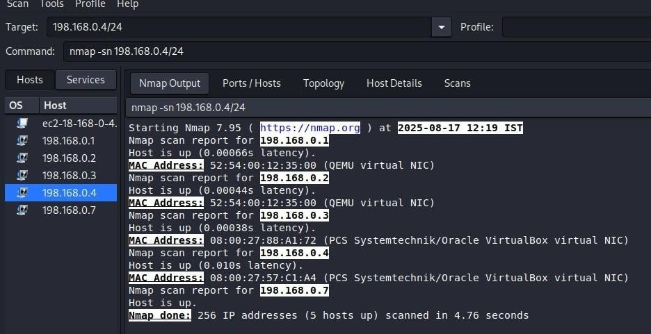
- This will show all live hosts in your subnet.

Expected Result:
You’ll see multiple hosts up (e.g., 198.168.0.1 router, 198.168.0.4 Metasploitable, maybe your Kali machine).

Generate a Topology Map
- If you have Zenmap (GUI for Nmap):

- Zenmap
- Run the same scan (nmap -sn 198.168.0.0/24).
- Go to the Topology Tab → It shows a network map diagram (nodes + links).

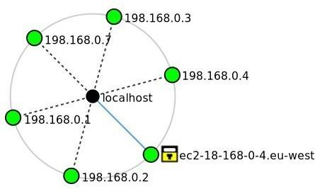
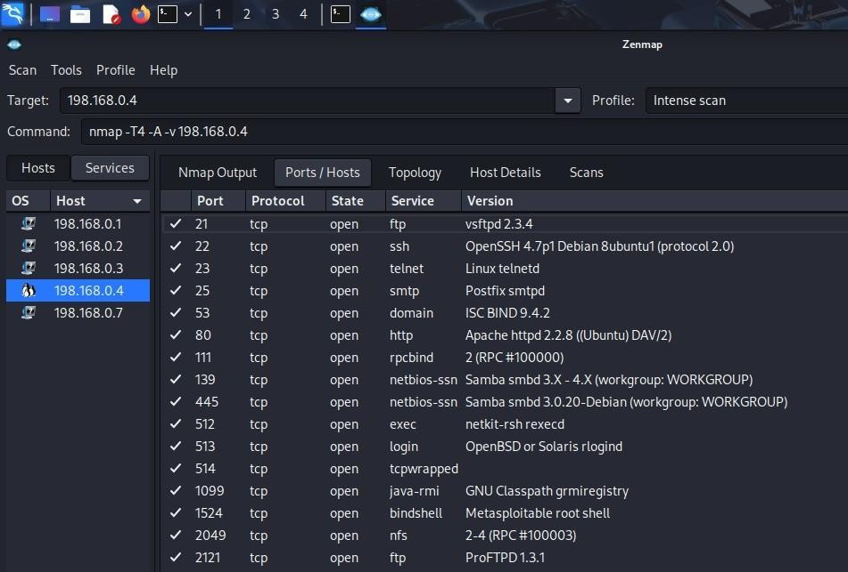
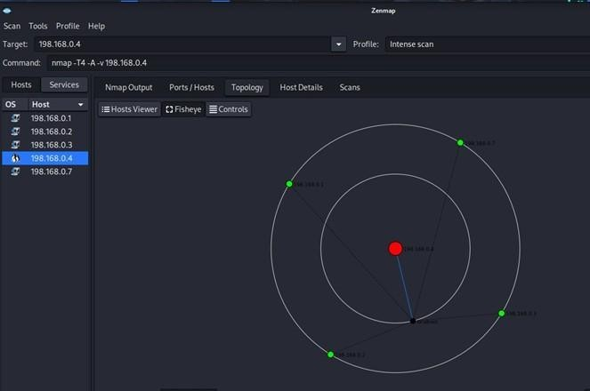
Expected Result:

You’ll have a visual map of the subnet with your target highlighted.

Lookup Domain Registry for IP Information
Goal: If you have a domain, find registration and owner info.

Understand Public vs. Private IPs
  - Before we run any commands, it's important to understand the IP address we are working with.
  - Metasploitable machine has the IP address 198.168.0.4. This is a private IP address.
  - Think of it like this:
A public IP is like the main mailing address of a large apartment building. Anyone in the world can send a letter to it.
A private IP is like an apartment number (e.g., "Apt 101") inside that building. That number is only useful inside the building. You can't send a letter from another city directly to "Apt 101."
  - The IP address 198.168.0.4 only exists and makes sense inside your isolated VirtualBox NAT Network. It is not reachable from the public internet.

Perform a Reverse DNS Lookup
- nslookup 198.168.0.4
Let's try to find a domain name associated with our target's IP. This is called a reverse DNS lookup.
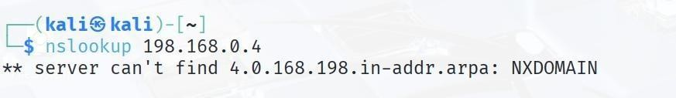
- This command asks a DNS server, "Which domain name points to the IP address 198.168.0.4?".
- The command will fail with a result like NXDOMAIN. This means "Non Existent Domain." This is the correct and expected outcome because a private IP address does not have a public domain name record.

Use whois and Understand Why It's Misleading

  - Now, we'll run the whois command and see why it produces a confusing result for our lab machine.
  - whois 198.168.0.4
  - The whois tool is designed to look up the registered owners of public IP addresses and domain names.

  - shows that this command returns ownership information for "Gwynedd Mercy

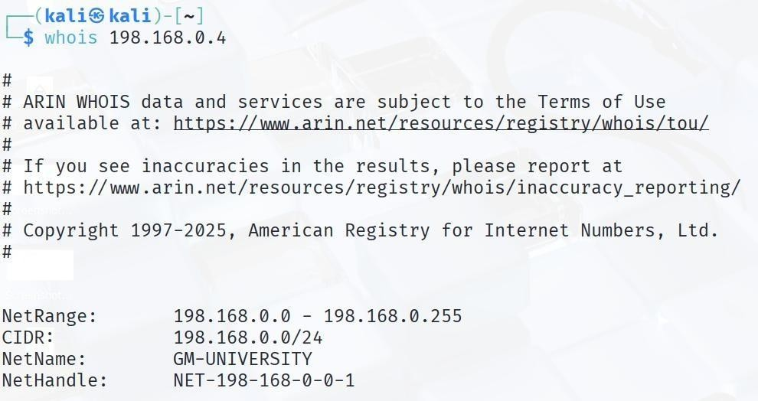
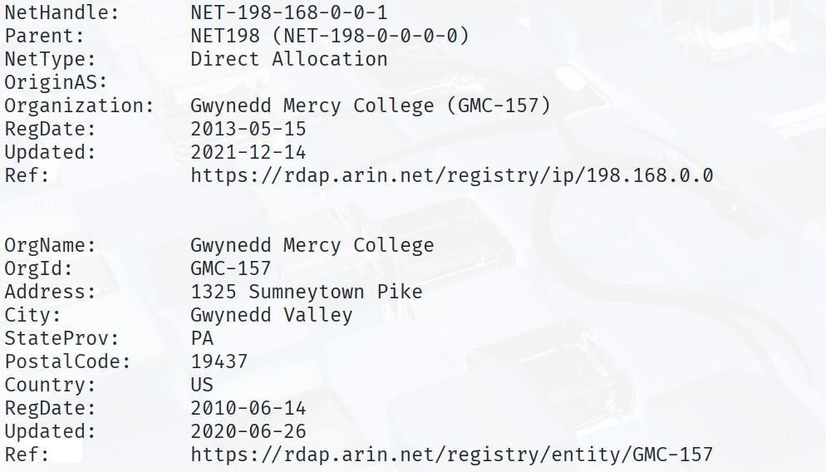
College". This is where it gets tricky:
  - This information is NOT for your virtual machine.
  - Because 198.168.0.4 is a private IP, it has no owner.
This command will show you the real, public registration data for the example.com domain, such as who the registrar is and when the domain was created.
  - The whois tool gets confused. It ignores that the IP is private and instead looks up the public IP block 198.168.0.0. By coincidence, this public block is registered to an organization.
  - Key Takeaway: The result is an artifact and is completely unrelated to your lab. You cannot find the "owner" of a private IP because millions of people use the same private IPs on their own home and office networks.

Use the Tools on a Real Public Target
  - To see how these tools are supposed to work, let's run them against a public domain, example.com. This is how you would use them in a real external penetration test.
  - Command 1: Find Public Ownership
- whois example.com

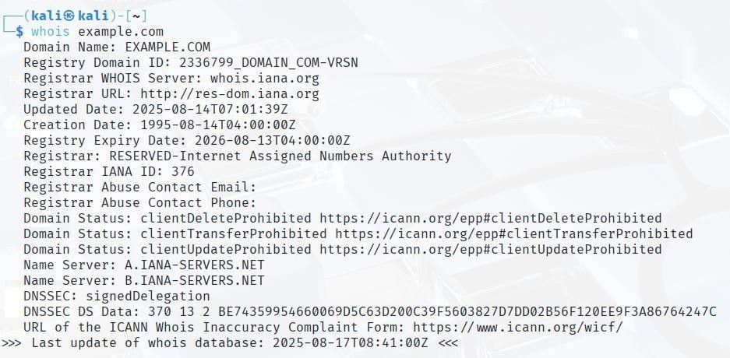
  - Command 2: Find Public DNS Records
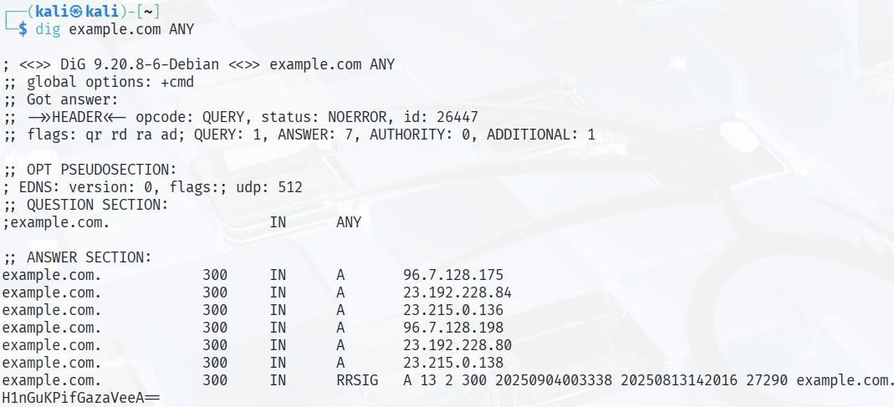
- dig example.com ANY
  - This command queries the public DNS servers for all available records for example.com, such as A records (IPv4 addresses), MX records (mail servers), and NS records (name servers). This gives you a map of the organization's public infrastructure.

Examining Use of IPv6 at Remote Location
Goal: See if the target has an IPv6 address.

Traceroute to Target
  - This shows the path your packets take to reach the target.
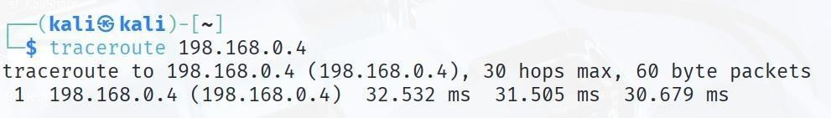
- traceroute 198.168.0.4

Output:
  - You’ll see a list of routers/hops with their IPs.

IPv6 Check
  - Run this to see if IPv6 is configured:
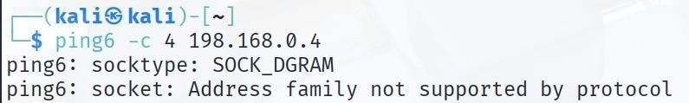
- ping6 -c 4 198.168.0.4

  - If the target has no IPv6, you’ll likely get an error like “unknown host” or “no route to host”.

  - ping6: socket: Address family not supported by protocol. This result indicates that the target host 198.168.0.4 is not configured for IPv6 communication or is not reachable over an IPv6 network from the attacker's position.

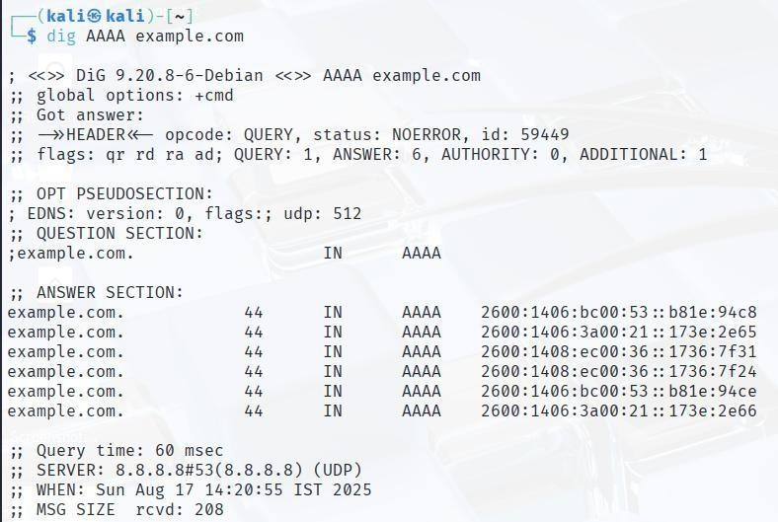
Or
Check AAAA records (IPv6) for a domain:
- dig AAAA example.com

  - If nothing comes back → No IPv6 in use.

If IPv6 found — scan it:
- nmap -6 -sV [IPv6 address]

Viva Questions

Q1: What is the main goal of external penetration testing?
A1: To identify and exploit vulnerabilities in an organization’s externally exposed assets (websites, servers, firewalls).

Q2: How can domain registry lookup help in reconnaissance?
A2: WHOIS lookups provide IP ranges, domain ownership, and contact details useful for attack surface mapping.

Q3: Why is IPv6 examination important during external testing?
A3: IPv6 may be deployed insecurely, and attackers can exploit unmonitored IPv6 services to bypass defenses.
Q4: What tools are commonly used for external penetration testing? A4: Nmap, Nikto, Burp Suite, Shodan, and Metasploit.

Q5: How does creating a topological map help in testing?
A5: It visualizes target systems, connections, and services, enabling better planning of attack paths.

Experiment 5: Different Types of Vulnerability Scanning

Objective: To explore and compare various vulnerability scanning techniques and tools, assessing their effectiveness in identifying and prioritizing security risks.

Introduction
Nmap (Network Mapper) is a powerful open-source tool used for network discovery and security auditing.

Installation
Nmap comes pre-installed on Kali Linux. To check: nmap --version

Usage Steps
- Identify the target IP using ifconfig/ip addr in the victim machine.
- Run a SYN scan to detect open ports.
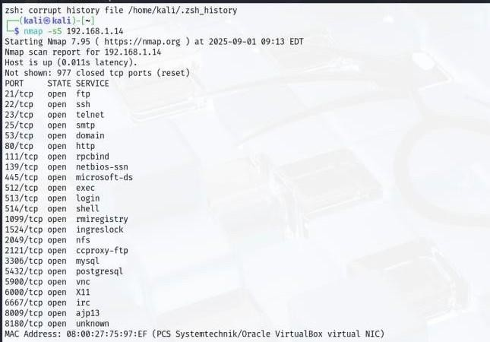
- Use service detection (-sS) to identify running services.
- Run vulnerability detection scripts
nmap -sV --script vuln 192.168.XX.XX -oN nmap_vuln.txt
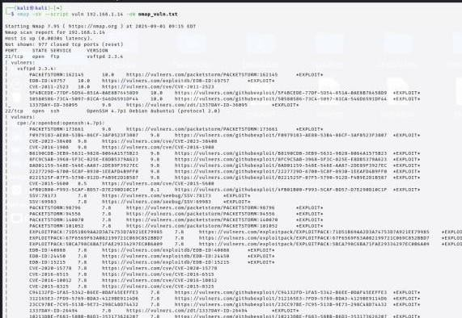

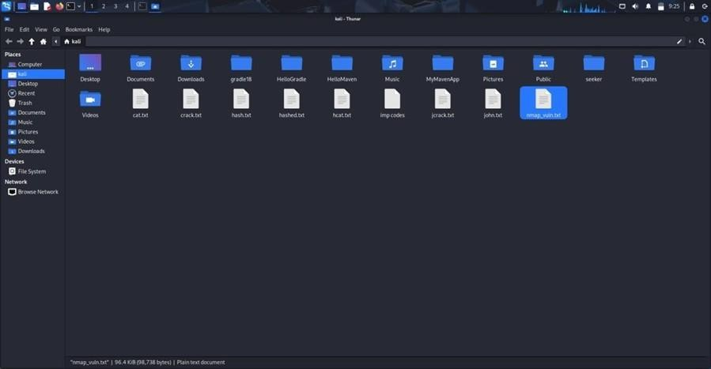
Example Command nmap -sV --script vuln
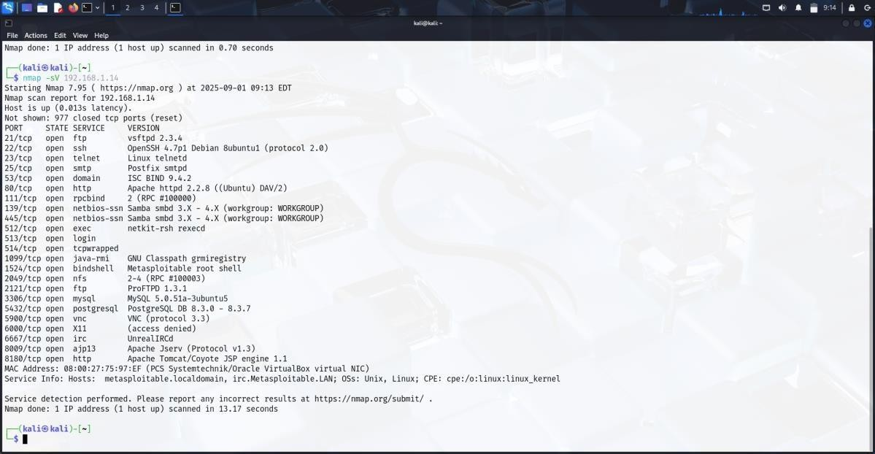
192.168.xx.xx

Expected Output
Output will show open ports, detected services, and potential vulnerabilities (CVEs, misconfigurations).

Viva Questions

- What is Nmap and what is it used for?
Answer: Nmap (Network Mapper) is an open-source tool used for network discovery and security auditing. It helps to scan networks to identify

live hosts, open ports, services running, and potential vulnerabilities.

How do you perform a basic scan using Nmap?
Answer: A basic scan can be performed by running the command: nmap
<target_ip_or_hostname> This scans the target for the most common 1000 TCP ports.

What is the difference between a TCP SYN scan and a TCP connect scan in Nmap?
Answer:
  - TCP SYN scan (-sS): Also called a “half-open” scan; it sends a SYN packet and waits for a SYN-ACK without completing the TCP handshake, making it stealthier.
  - TCP connect scan (-sT): Completes the full TCP handshake by connecting to the target ports; it’s less stealthy but works when SYN scan requires root privileges.

- How can you use Nmap to detect the operating system of a target machine? Answer: You can use the -O option to enable OS detection: nmap -O <target_ip> This uses TCP/IP stack fingerprinting to guess the target’s operating system.

What does the -p option do in an Nmap command?
Answer: The -p option specifies the port(s) to scan. For example: nmap -p 22,80,443
<target_ip> This scans only ports 22, 80, and 443.

Introduction

Nikto is an open-source web server scanner that performs comprehensive tests against web servers for multiple vulnerabilities. It checks for over 6700 potentially dangerous files/programs, outdated server versions, and other security issues.

Key Features
  - Detects outdated server software versions.
  - Identifies potentially dangerous files and scripts.
  - Detects misconfigured servers and security issues.

Usage Examples

- Below are some commonly used Nikto commands:
- Basic HTTP Scan:
- nikto -h http://<target-ip>

4 Common Options

- h <host> → Target host or URL -o <file> → Output results to a file
- Format <htm|txt|xml|csv> → Select report format

- Plugins → Select or limit plugin categories --help → Show all available options
- Save Report as HTML: nikto -h http://<target-ip> -o ~/nikto_output.html -Format htm
- Scan Specific Port: nikto -h http://<target-ip>:8080
- HTTPS Scan: nikto -h https://<target-ip>
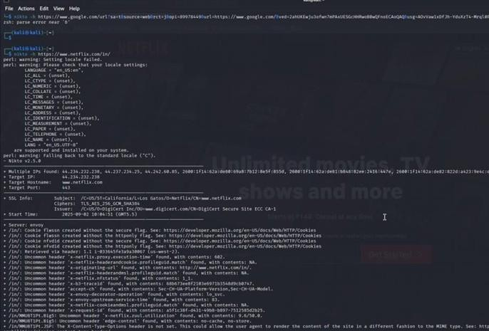

Experiment 6: Vulnerability Scanning with Nessus

Objective: To utilize Nessus for comprehensive vulnerability scanning, identifying security weaknesses in systems and providing recommendations for remediation.

Installation of Nessus

  - Go to Tenable’s website.
  - Save the installer file to your Downloads folder.
  - Download the Debian (.deb) installer for Linux and note down your activation code.

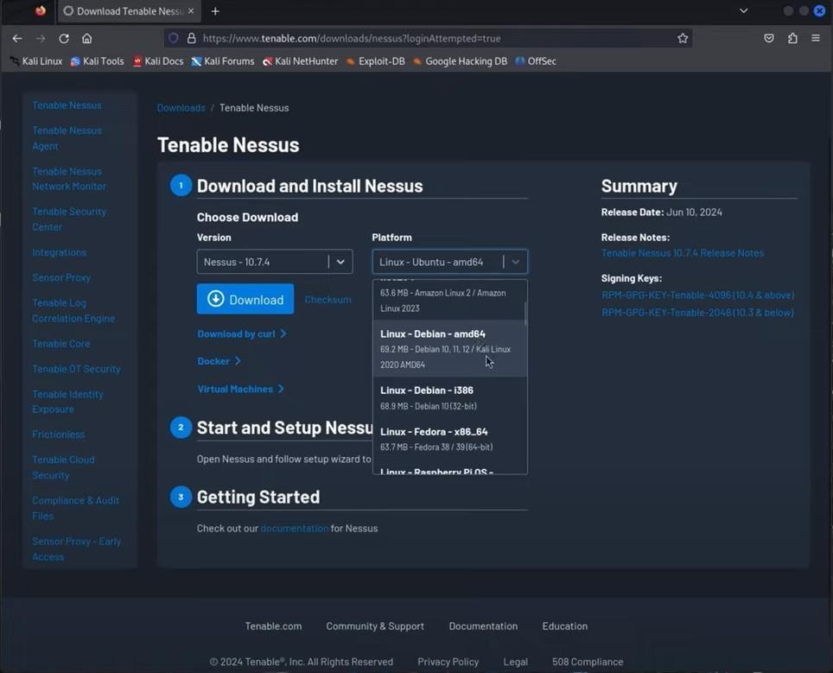

Install the Package
  - Open the terminal and go to the Downloads folder:
  - cd ~/Downloads
  - Install the package (replace filename with your downloaded file):
  - sudo dpkg -i Nessus-<version>-debian_amd64.deb

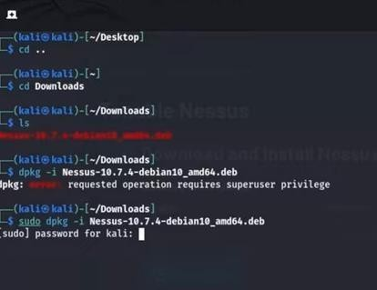

Start Nessus Service
  - Start the Nessus service:
  - sudo systemctl start nessusd
  - Check it’s running:
  - sudo systemctl status nessusd
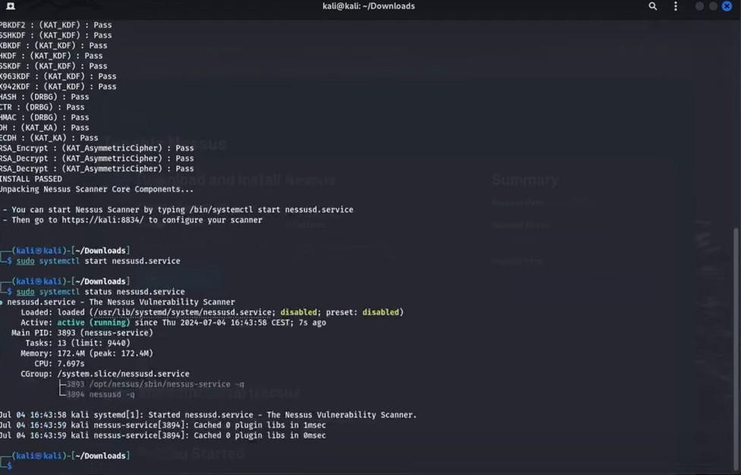

Open the Web Interface
  - https://localhost:8834
  - Accept the security warning

Follow the setup wizard:
- Choose edition (Essentials/Professional).
- Enter the activation code.

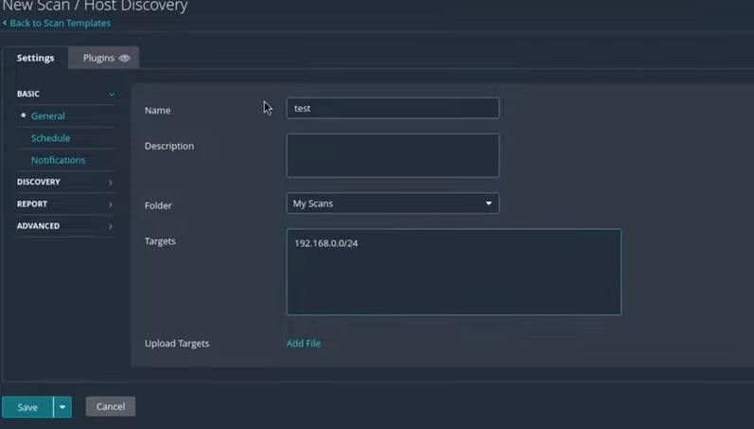
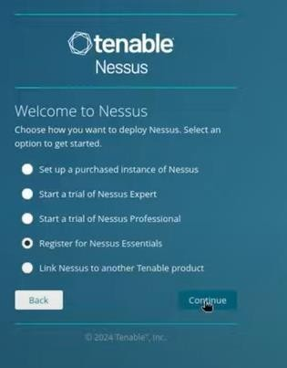
- Create an admin username and password.

Let Plugins Download
  - Wait a few minutes for Nessus to download plugins (this may take time).

Create and Run First Scan
- Log into Nessus web UI.
- Click on 'Scans' → 'New Scan'.
- Choose 'Basic Network Scan'.
- Enter a scan name and target IP(s).
- Optional: Add SSH/Windows credentials for deeper scans.
- Save and launch the scan.

View and Export Results
  - When scan finishes, open it to see findings.
  - Issues are grouped by severity:
  - Critical → High → Medium → Low.
  - Click a finding for details (CVE, CVSS score, fix instructions).
  - Export report as PDF, HTML, CSV, or .nessus format.
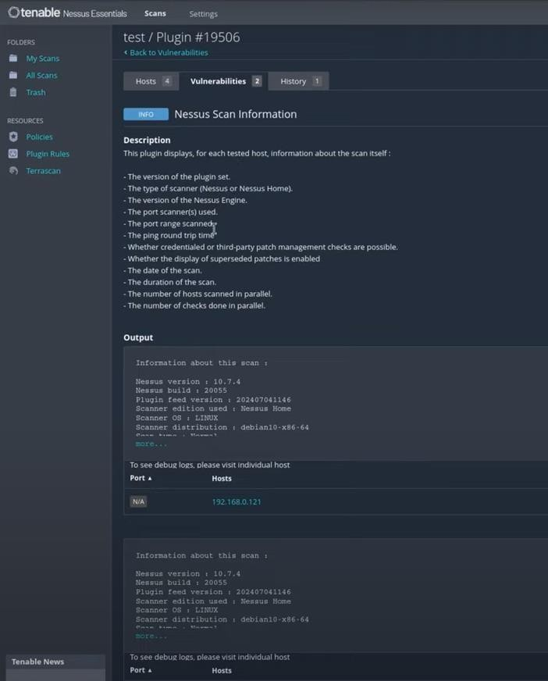

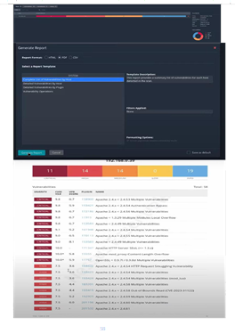

Best Practices
  - Run credentialed scans for accurate results when possible.
  - Always scan only the systems you own or have permission to test.
  - Update Nessus regularly to get the latest vulnerability checks.

Viva Questions

- What is Nessus used for?
Nessus is a vulnerability scanner that detects security weaknesses in operating systems, applications, and networks. It also provides remediation recommendations.

How do you access Nessus after installation on Kali Linux?
You access it via a web browser at https://kali:8834/ (or https://127.0.0.1:8834/) after starting the Nessus service.

What is the difference between Nessus Essentials and Nessus Professional?
Nessus Essentials is free and allows scanning up to 16 IPs, while Nessus Professional is a paid version with advanced features for enterprises.

What types of vulnerabilities can Nessus detect?
Nessus can detect misconfigurations, missing patches, outdated software, weak passwords, open ports, and compliance issues.

Why is Nessus considered more powerful than tools like Nmap?
Nmap mainly detects open ports and services, while Nessus goes further by
identifying known vulnerabilities, misconfigurations, and suggesting remediation steps.

Experiment 7: Web application vulnerability assessment using Nikto and Burpsuite

Objective: To evaluate web applications for security vulnerabilities using Nikto and Burp Suite, identifying issues such as misconfigurations and common vulnerabilities in web applications.

Introduction
Nikto is an open-source web server scanner that performs comprehensive tests against web servers. It checks for over 6700 potentially dangerous files/programs, outdated versions, and server configuration issues. This lab guides students in performing a web application vulnerability assessment using Nikto.

Objectives
- To understand the usage of Nikto for vulnerability assessment.
- To perform scanning of a target web application.
- To identify possible misconfigurations and vulnerabilities.

Requirements
  - Kali Linux (or any system with Nikto installed)
  - Internet connection
  - A test web application or server for scanning
  - Basic knowledge of command-line interface

Procedure
Step 1: Open Terminal in Kali Linux.

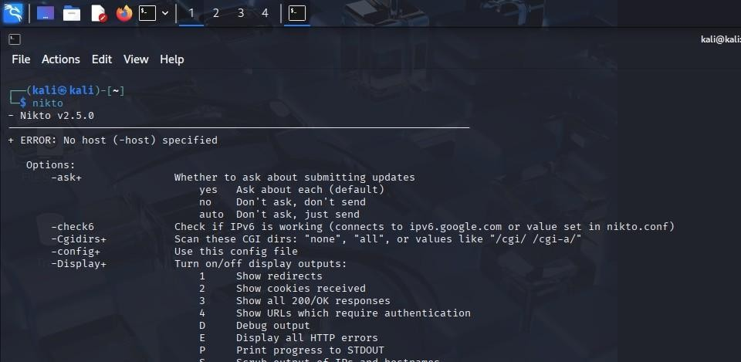

Step 2: Run the Nikto command without specifying a host to view available options. Command:
nikto
This will display the help menu and usage instructions, as shown below:
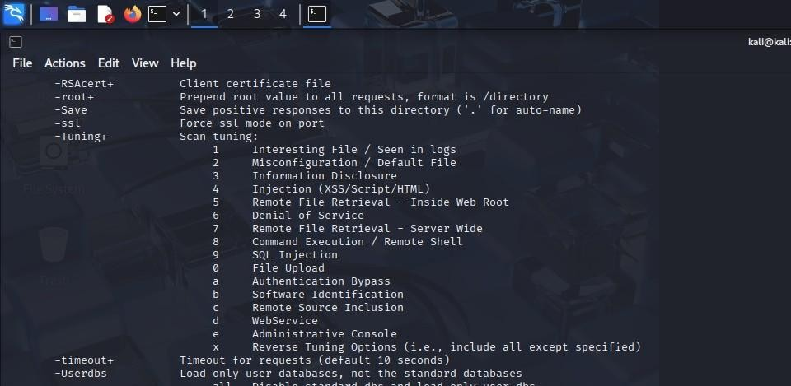

Step 3: Run a scan on the target web application using the following command: Command:
nikto -h <target_host> -p <port> Example:
nikto -h thestudentscircle.com -p 80

Step 4: Observe the scan results. Nikto will display information about server configuration, missing headers, outdated software, and other potential vulnerabilities.
Step 5: Analyze the findings and prepare a report on the identified vulnerabilities. Provide recommendations for mitigation based on the scan results.

Using Burpsuite Objective:
To learn how to use the Burp Suite Intruder tool to perform a basic dictionary (brute-force) attack against a web application's login form to discover a valid password.

Prerequisites:
- Burp Suite Community Edition installed.

- A modern web browser (Burp's built-in Chromium browser is recommended).
- A target web application for testing purposes (e.g., testphp.vulnweb.com). Note: Only perform attacks on applications you own or have explicit permission to test.

Procedure

Step 1: Setup and Configuration
- Launch Burp Suite.
- If prompted, select a temporary project and click Next, then Start Burp.
- Navigate to the Proxy tab and then the Intercept sub-tab.
- Click the Open Browser button. This will launch a pre-configured Chromium browser that routes all traffic through Burp Suite.
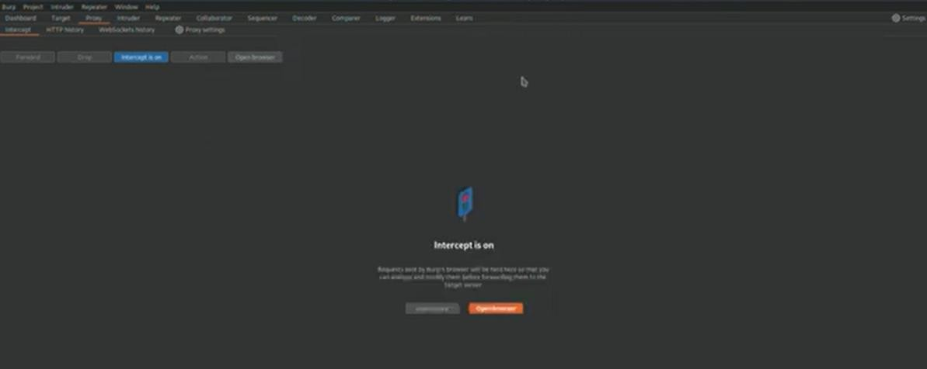

Step 2: Capture a Login Request
  - In the Burp browser, navigate to your target website's login page (e.g., http://testphp.vulnweb.com/login.php).
  - Go back to Burp Suite and ensure the Intercept is on button is active.
  - Return to the browser. In the login form, enter any incorrect username and password (e.g., username: test, password: password).
  - Click the login button. The request will be intercepted and paused in Burp Suite.
  - In Burp Suite, you can now see the raw HTTP request. Click the Forward button until the request is sent, and then click Intercept is on to disable it. This makes it easier to work with the captured history.

Go to the Proxy -> HTTP history tab. You should see a POST request for the login page (e.g.,
/login.php or /userinfo.php). This is the request we will use for our attack

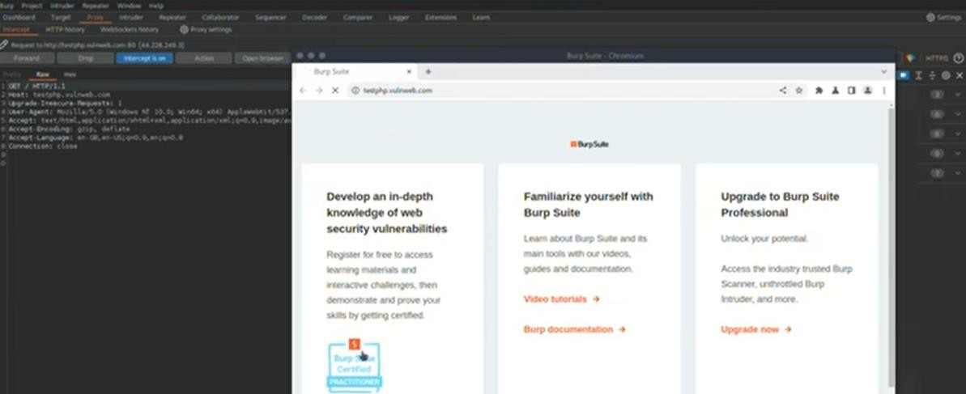

Step 3: Send Request to Intruder
- In the HTTP history list, find and right-click on the POST login request.
- From the context menu, select Send to Intruder. A notification will appear, and the "Intruder" tab will be highlighted.

Step 4: Configure Intruder Positions
- Go to the Intruder tab. You will see four sub-tabs: Positions, Payloads, Resource Pool, and Settings.
- By default, Burp Intruder automatically marks several potential payload positions with § symbols. We only want to attack the password parameter.
- First, click the Clear § button on the right to remove all default selections.
- In the request editor, find the line with the password you entered (e.g., pass=password).
- Highlight the value of the password parameter (the word password itself).
- Click the Add § button. The parameter should now look like pass=§password§. This tells Intruder to insert its payloads only at this specific position.

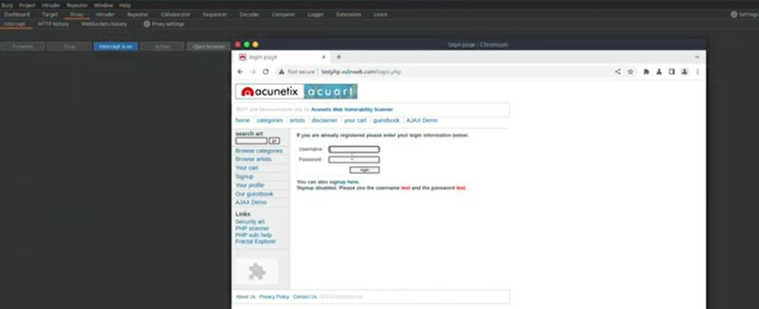

Step 5: Configure Intruder Payloads
- Click on the Payloads sub-tab.
- Under Payload sets, keep the Payload type as Simple list.
- Under Payload settings [Simple list], you can add your potential passwords. Click Add and type in common passwords, one by one. For this lab, add the following:
- admin
- 1234
- root
- test
- guest
- adm
- You can also use the Load button to import a larger wordlist from a file.
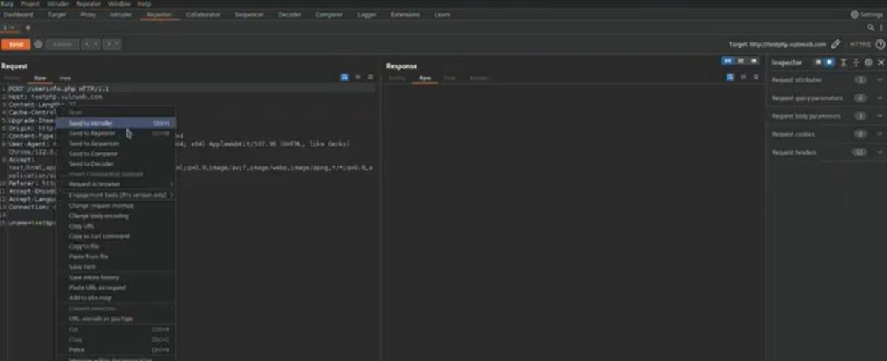

Step 6: Launch the Attack
- Once your positions and payloads are configured, click the Start attack button in the top-right corner.
- A new window titled "Intruder attack" will open. Burp Suite Community Edition will throttle the attack, but for a small list, it will be quick.
- The attack window will populate with a table showing each request made, using one payload from your list at a time.

Step 7: Analyze the Results
- In the Intruder attack window, observe the columns for Status and Length.
- Most incorrect login attempts will likely return the same status code (e.g., 200 OK) and have the same response length (the size of the "Login failed" page).
- Look for a request that has a different Status code (like 302 Found, indicating a redirect) or a significantly different Length. This anomaly often indicates a successful login.
- Click on the anomalous request in the table. You can then view the server's Response in the panel below to confirm if it indicates success (e.g., a "Welcome" message or a redirect to a user dashboard).
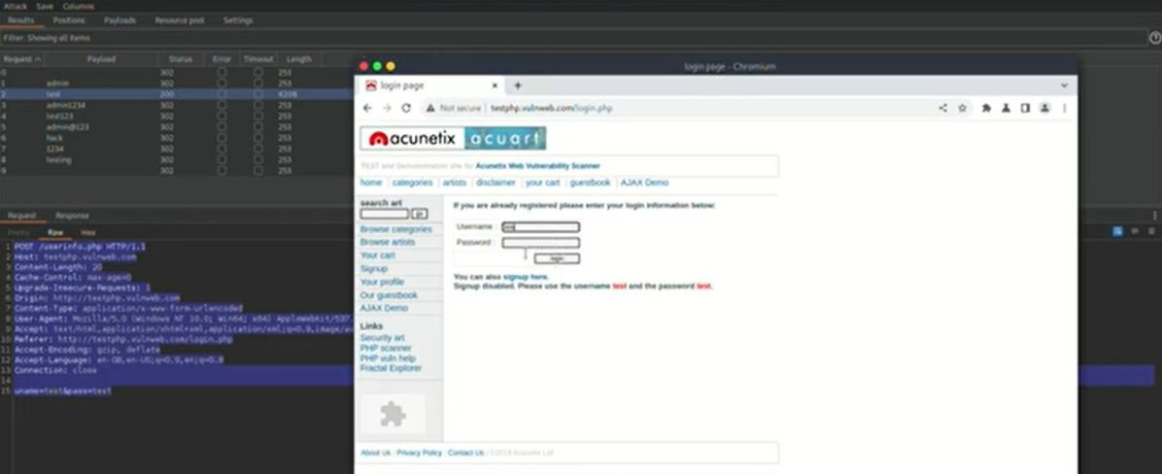

Viva Questions:

- What is Nikto and why is it used? Answer:
Nikto is an open-source web server scanner used for web vulnerability assessment. It identifies misconfigurations, outdated software, insecure files, dangerous scripts, and missing security headers. It is widely used in penetration testing to detect common web server vulnerabilities.

What is Web Application Vulnerability Assessment and why is it important? Answer:
Web Application Vulnerability Assessment is the process of identifying, analyzing, and reporting security weaknesses in web applications. It is important because web applications are exposed to the internet and can be attacked by hackers, leading to data breaches,

unauthorized access, and financial loss. Detecting vulnerabilities early helps prevent exploitation.

What type of vulnerabilities can Nikto detect? Answer:
Nikto can detect:
  - Outdated web server software versions
  - Insecure HTTP headers (e.g., missing X-Frame-Options)
  - Common misconfigurations
  - Dangerous files or directories
  - Potential injection points (e.g., XSS, SQLi indicators)

What are the common types of web application vulnerabilities? Answer:
Some common vulnerabilities include:
- SQL Injection: Attacker injects malicious SQL queries into input fields.
- Cross-Site Scripting (XSS): Injecting malicious scripts into web pages viewed by users.
- Cross-Site Request Forgery (CSRF): Forces users to perform unwanted actions.
- Broken Authentication: Weak session management or credential issues.
- Security Misconfiguration: Incorrect server or application settings.

What is the role of Burp Suite in vulnerability assessment? Answer:
Burp Suite is an integrated platform used for web application security testing. Its main functions include:
- Intercepting HTTP/S requests and responses.
- Scanning for vulnerabilities like XSS, SQL Injection.
- Performing attacks like brute force using Intruder.
- Modifying requests for manual testing.

